# VISVESVARAYA TECHNOLOGICAL UNIVERSITY

**“JnanaSangama”, Belgaum -590014, Karnataka.**



**LAB REPORT**

**on**

COMPUTER NETWORKS

***Submitted by***

**VIBHA HUGAR (1BM21CS255)**

***in partial fulfillment for the award of the degree of***

**BACHELOR OF ENGINEERING**

***in***

**COMPUTER SCIENCE AND ENGINEERING**



**B.M.S. COLLEGE OF ENGINEERING**

**(Autonomous Institution under VTU)**

**BENGALURU-560019 JUN-2023 to SEP-2023**

1

**B. M. S. College of Engineering,**

**Bull Temple Road, Bangalore 560019**

(Affiliated To Visvesvaraya Technological University, Belgaum)

**Department of Computer Science and Engineering**



**CERTIFICATE**

This is to certify that the Lab work entitled “COMPUTER NETWORKS” carried out by **VIBHA HUGAR (1BM21CS255),** who is a bonafide student of **B. M. S. College of Engineering.** It is in partial fulfillment for the award of **Bachelor of Engineering in Computer Science and Engineering** of the Visvesvaraya Technological University, Belgaum during the year 2023. The Lab report has been approved as it satisfies the academic requirements in respect of a **Computer Networks - (22CS4PCCON)** work prescribed for the said degree.

**Shravya Raj Dr. Jyothi S Nayak**

Assistant Professor Professor and Head

Department of CSE Department of CSE

BMSCE, Bengaluru BMSCE, Bengaluru

`

2

# Index

|  |  |  |
| --- | --- | --- |
| **Sl.**  **No.** | **Experiment Title** | **Page No.** |
|  | **CYCLE 1** |  |
| 1 | Create a topology and simulate sending a simple PDU from source to destination using hub and switch as connecting devices and demonstrating ping messages. | 4 |
| 2 | Configure IP address to routers in packet tracer. Explore  the following messages: ping responses, destination unreachable, request timed out, reply. | 10 |
| 3 | Configure default route, static route to the Router. | 18 |
| 4 | Configure DHCP within a LAN and outside LAN. | 23 |
| 5 | Configure Web Server, DNS within a LAN. | 30 |
| 6 | Configure RIP routing Protocol in Routers. | 33 |
| 7 | Configure OSPF routing protocol. | 38 |
| 8 | To construct simple LAN and understand the concept and operation of Address Resolution Protocol (ARP). | 43 |
| 9 | To construct a VLAN and make a pc communicate among VLAN. | 47 |
| 10 | Demonstrate the TTL/ Life of a Packet. | 51 |
| 11 | To construct a WLAN and make the nodes communicate wirelessly. | 55 |
| 12 | To understand the operation of TELNET by accessing the router in server room from a PC in IT office. | 60 |
|  | **CYCLE 2** |  |
| 13 | Write a program for error detecting code using CRC CCITT (16-bits). | 63 |
| 14 | Write a program for congestion control using Leaky  bucket algorithm. | 67 |
| 15 | Using TCP/IP sockets, write a client-server program to  make client sending the file name and the server to send back the contents of the requested file if present. | 70 |
| 16 | Using UDP sockets, write a client-server program to make client sending the file name and the server to send back the contents of the requested file if present. | 73 |
| 17 | Tool Exploration -Wireshark | 75 |

3

# WEEK 1

Create a topology and simulate sending a simple PDU from source to destination using hub and switch as connecting devices and demonstrate ping messages.

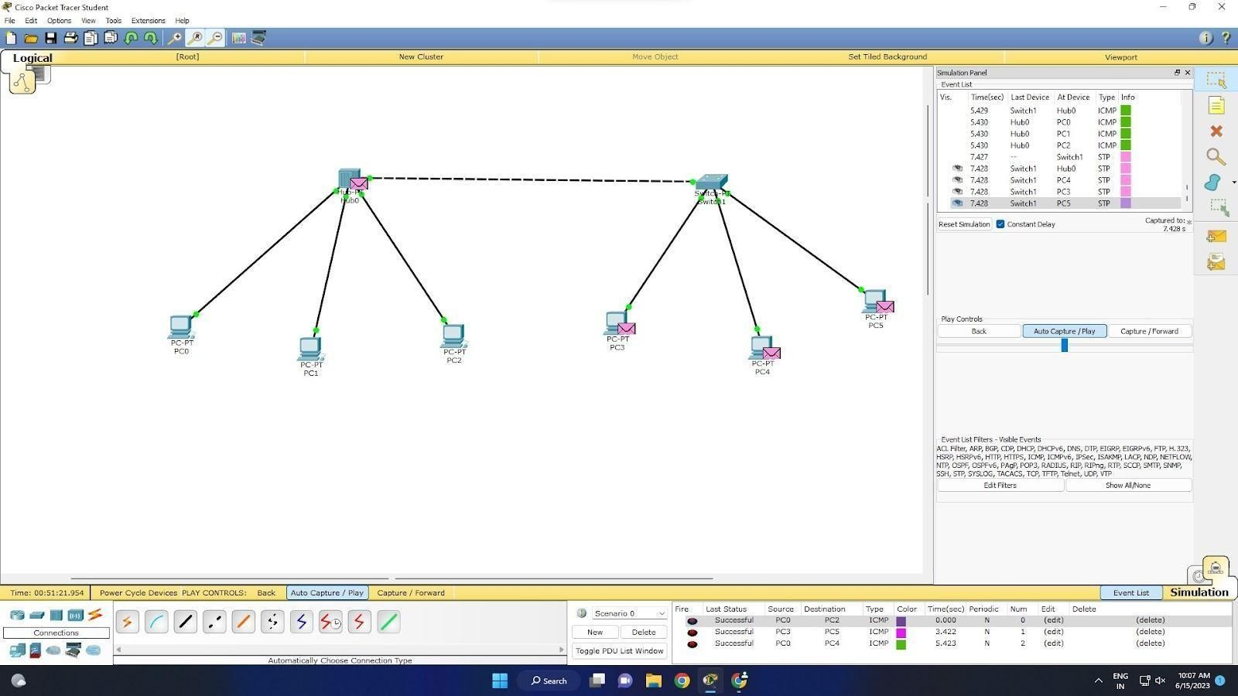TOPOLOGY:

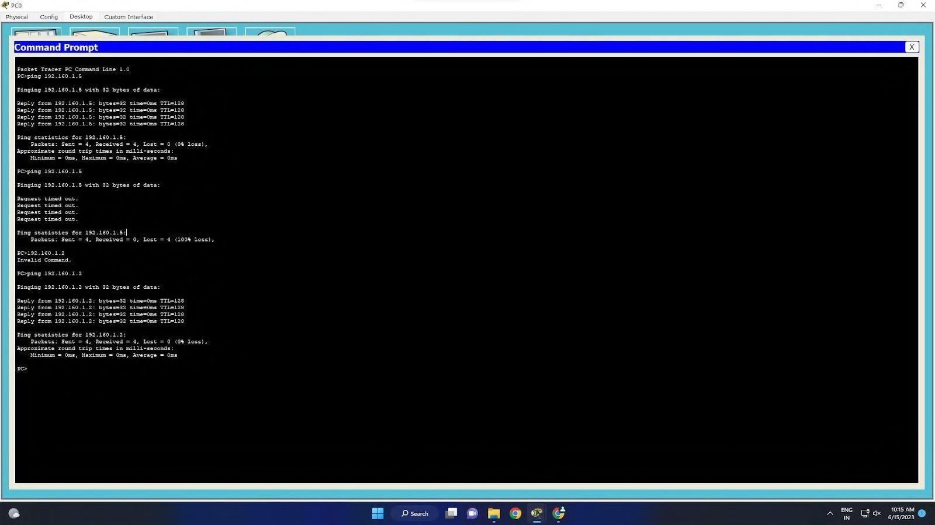OUTPUT:

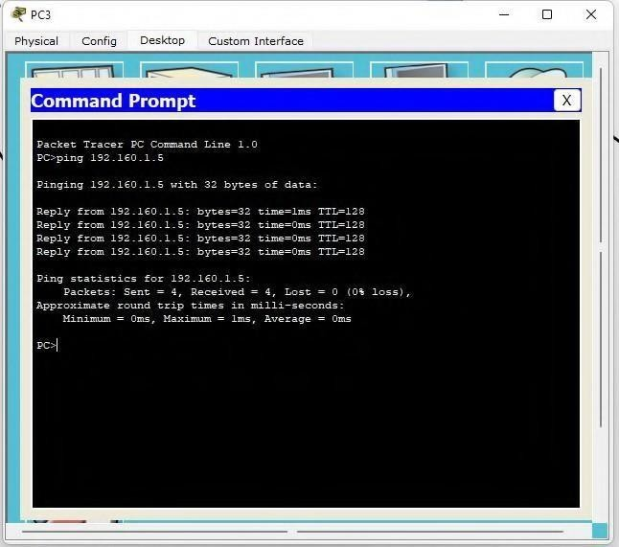

# WEEK 2

Configure IP address to routers (one and three) in packet tracer. Explore the following messages: ping responses, destination unreachable, request timed out, reply.

TOPOLOGY:

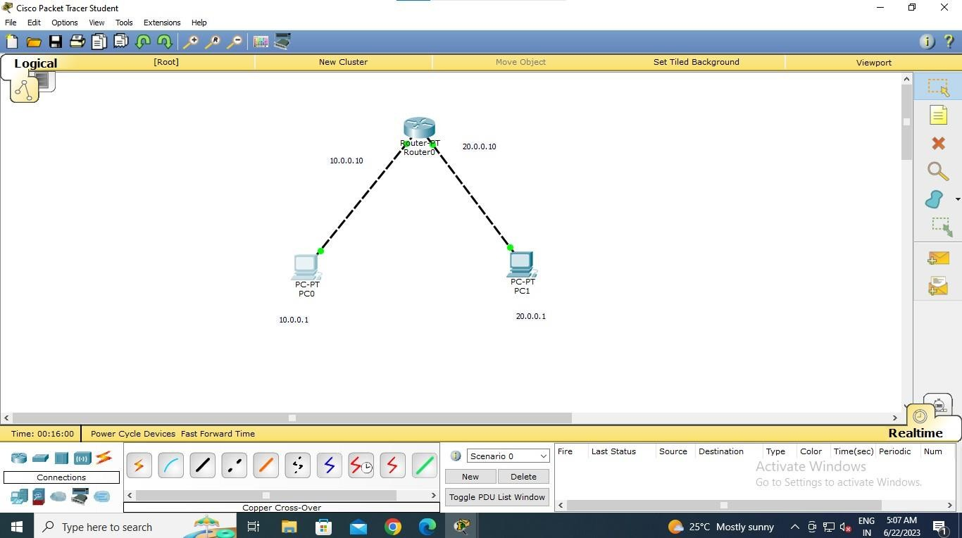PROGRAM 2.1

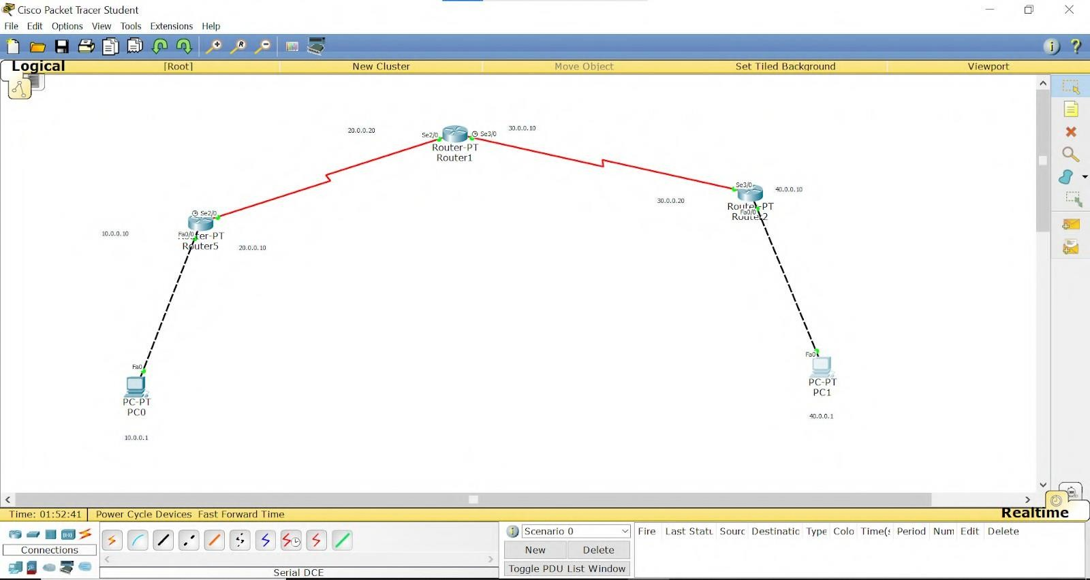PROGRAM 2.2

OUTPUT:

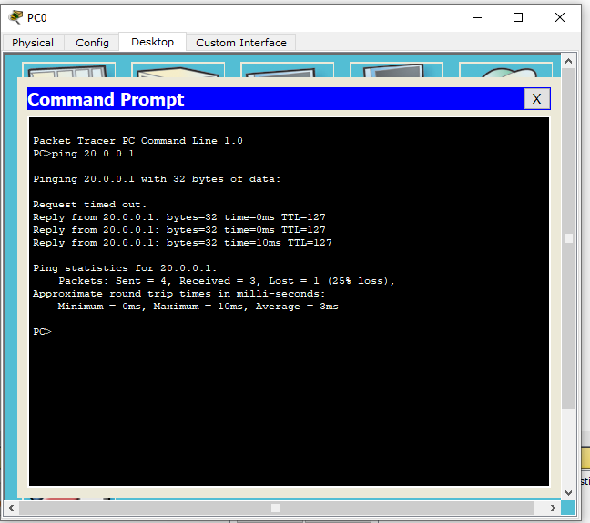PROGRAM 2.1

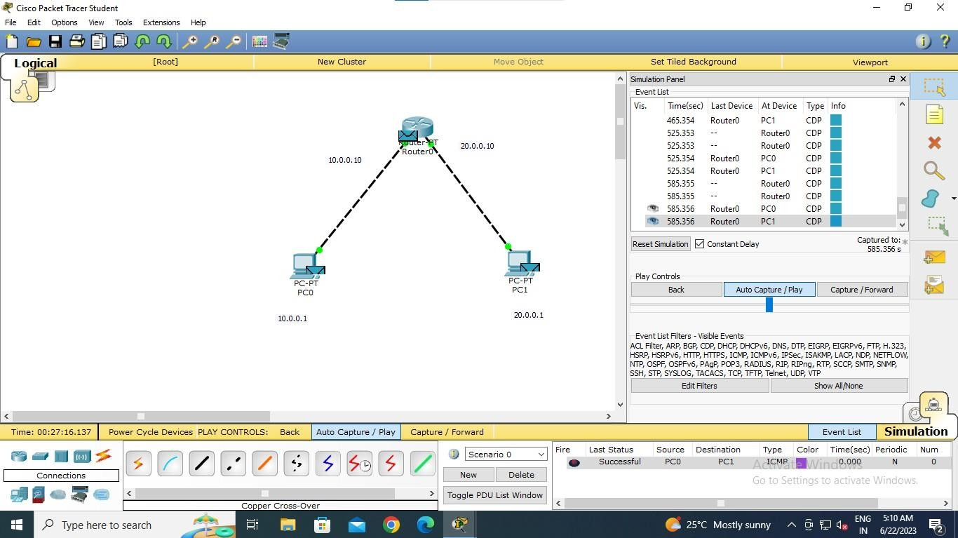

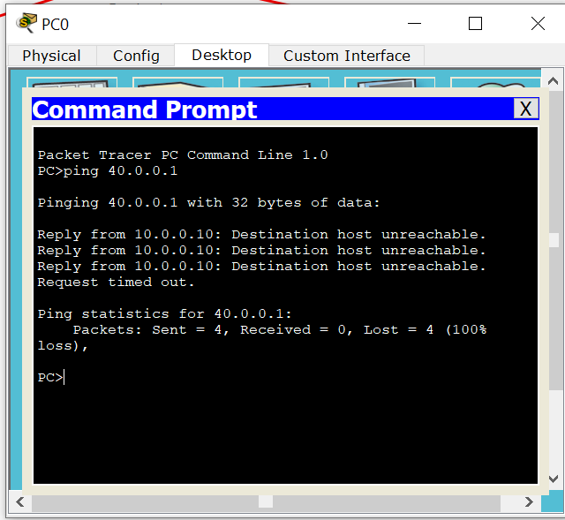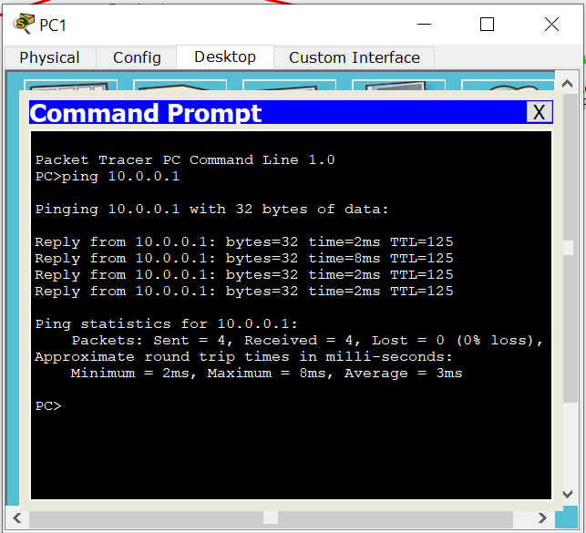PROGRAM 2.2

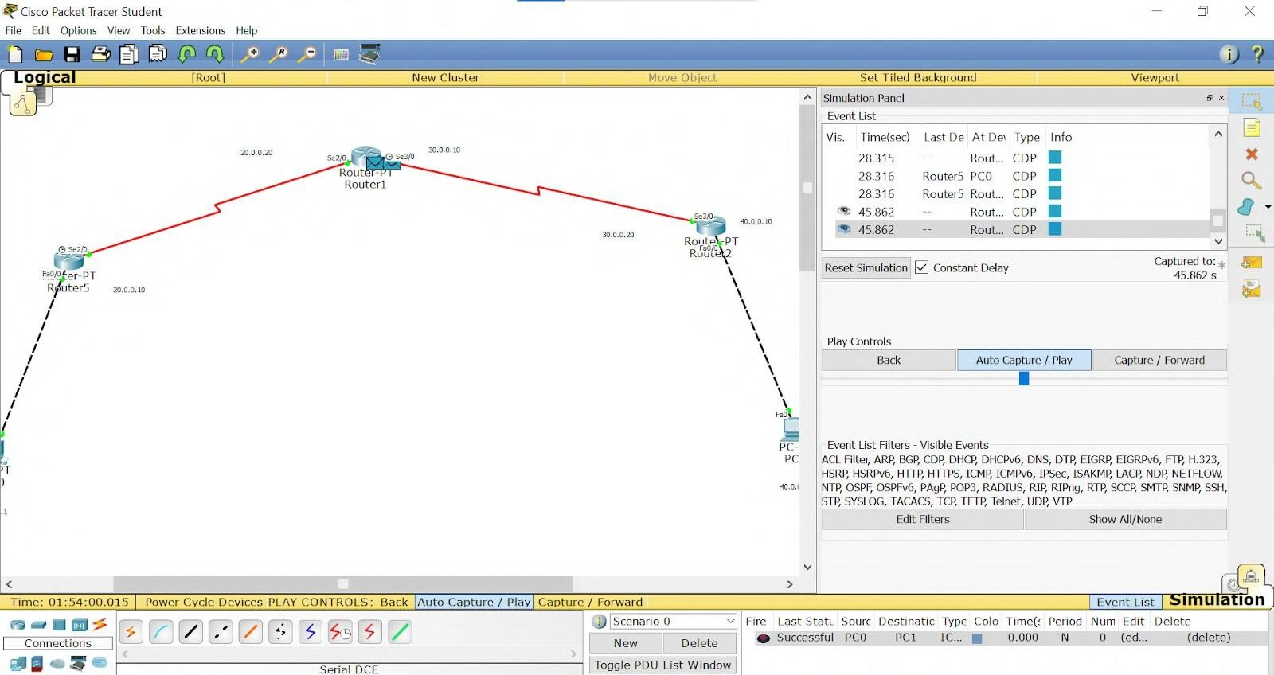

# WEEK 3

Configure default route, static route to the Router.

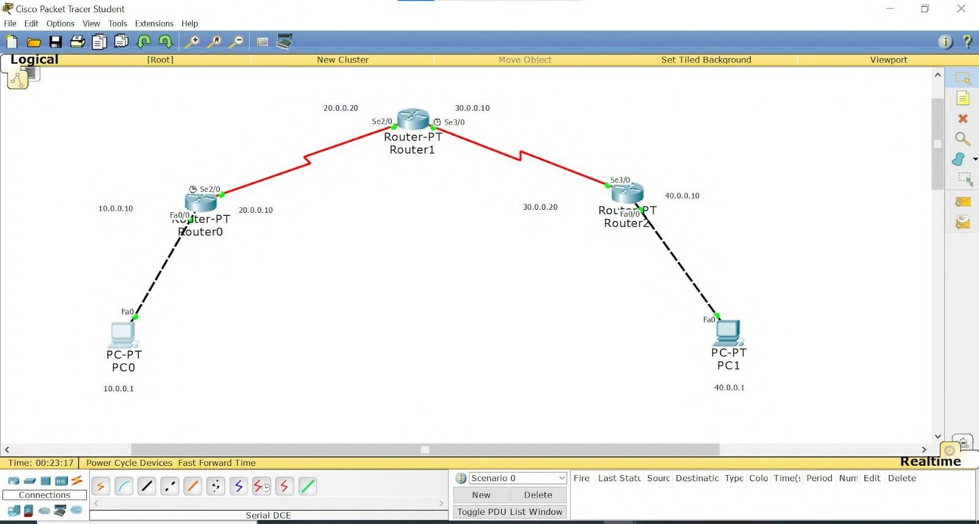TOPOLOGY:

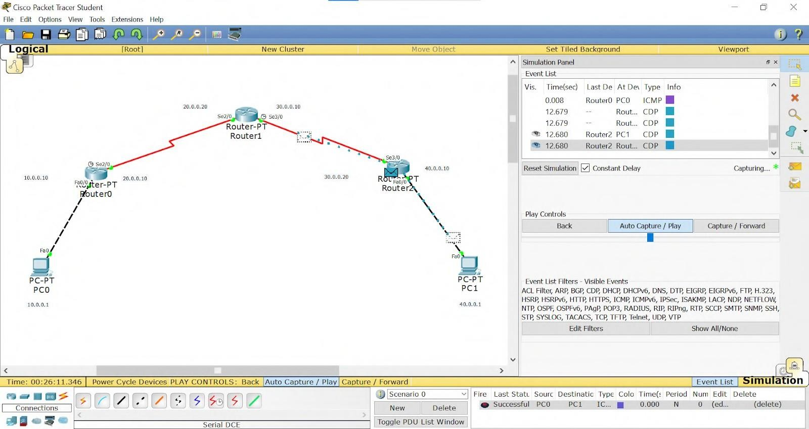OUTPUT:

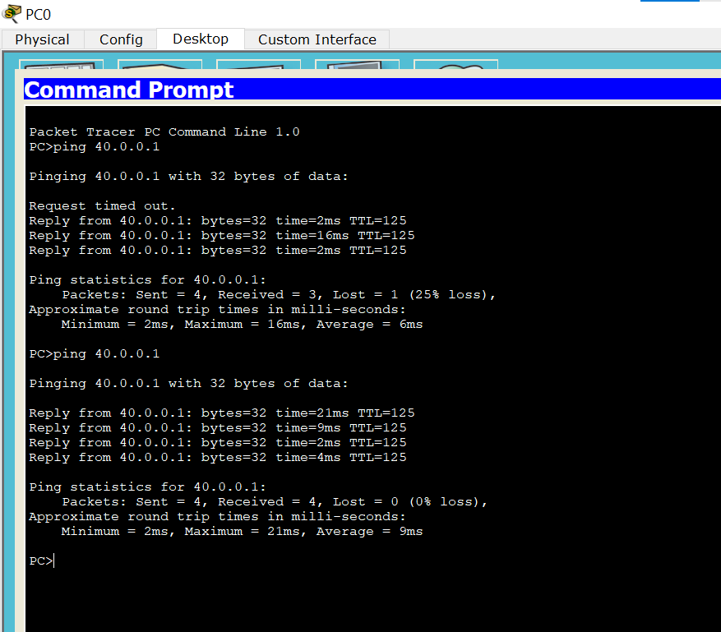

# WEEK 4

Configure DHCP within a LAN and outside LAN.

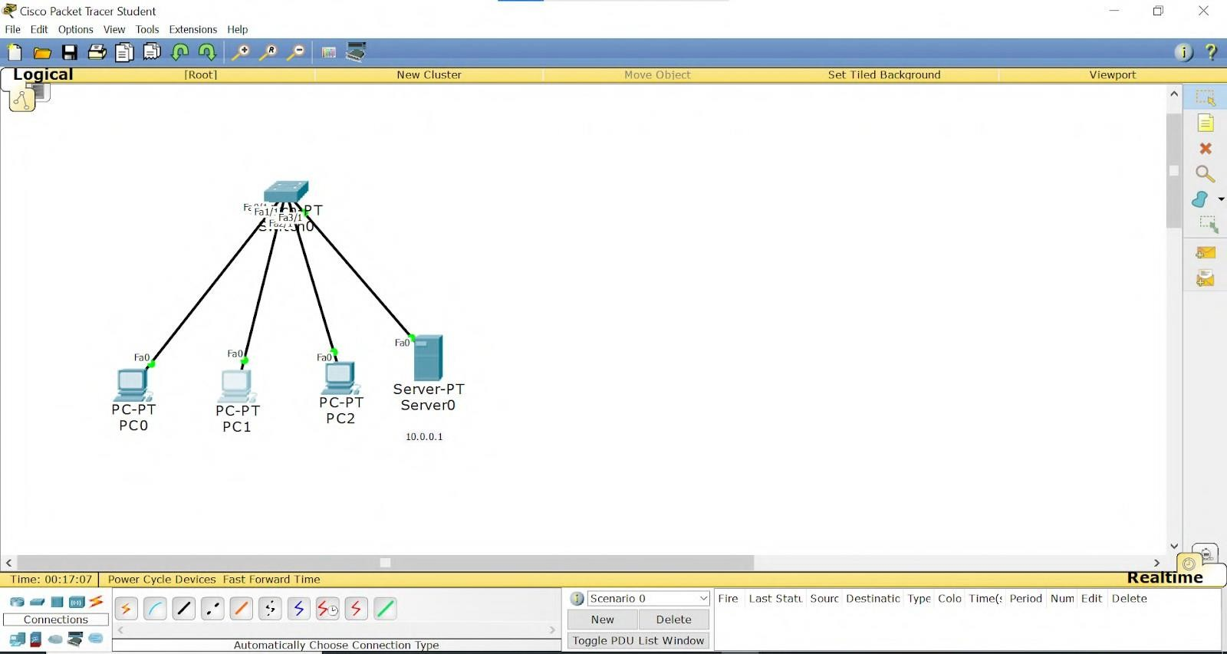TOPOLOGY: PROGRAM 4.1:

PROGRAM 4.2:

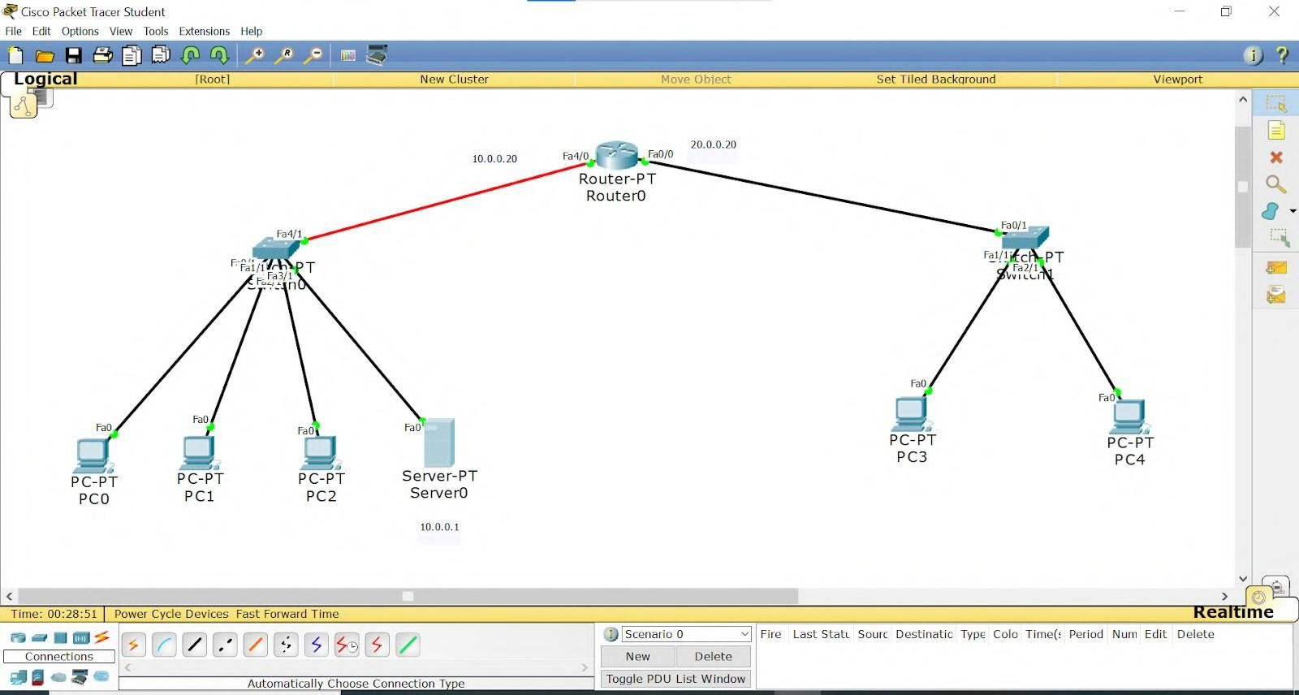

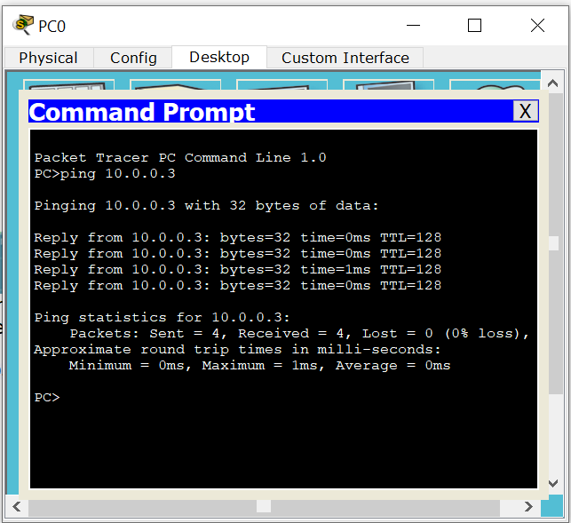OUTPUT: PROGRAM 4.1:

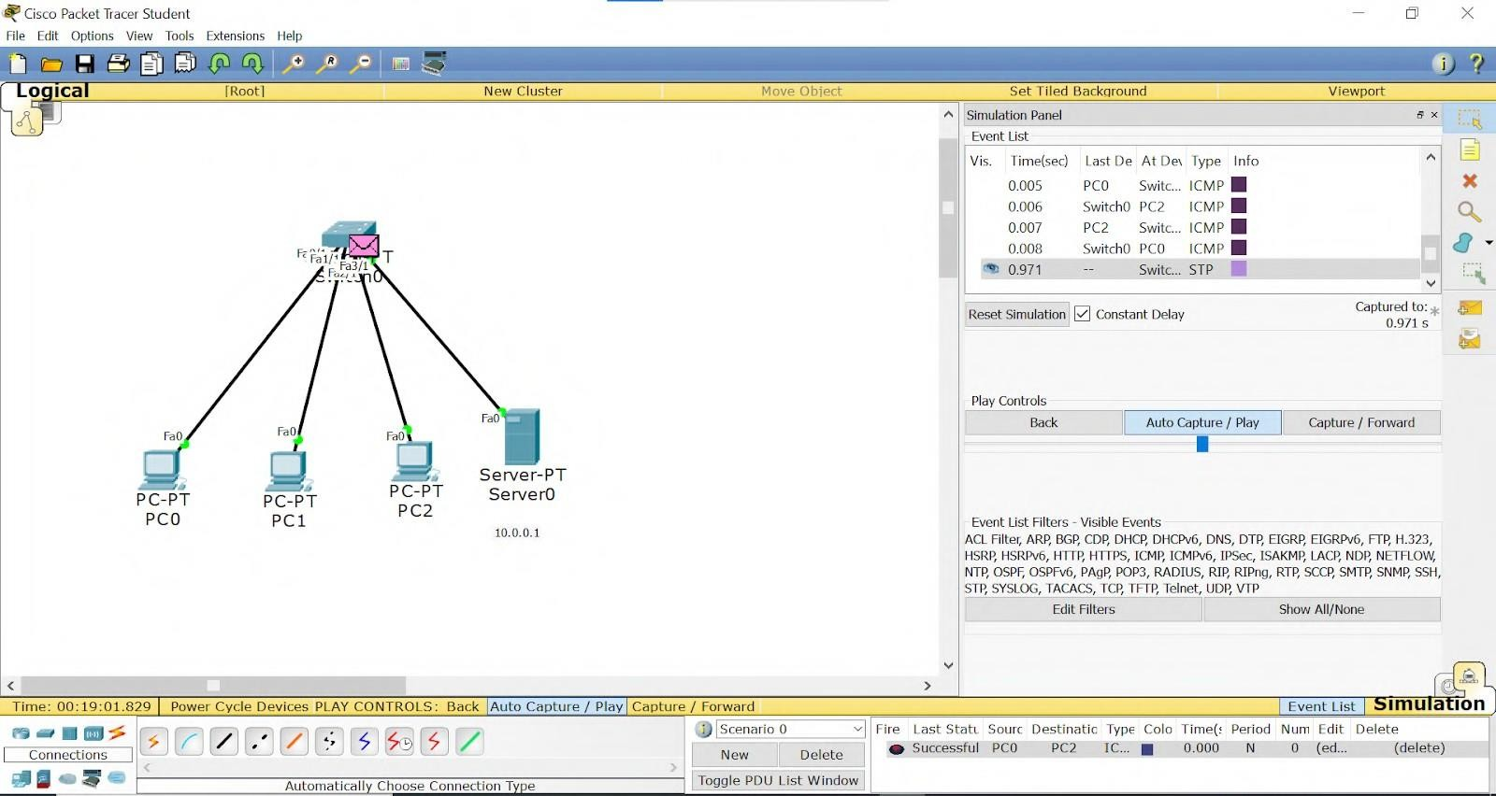

PROGRAM 4.2:

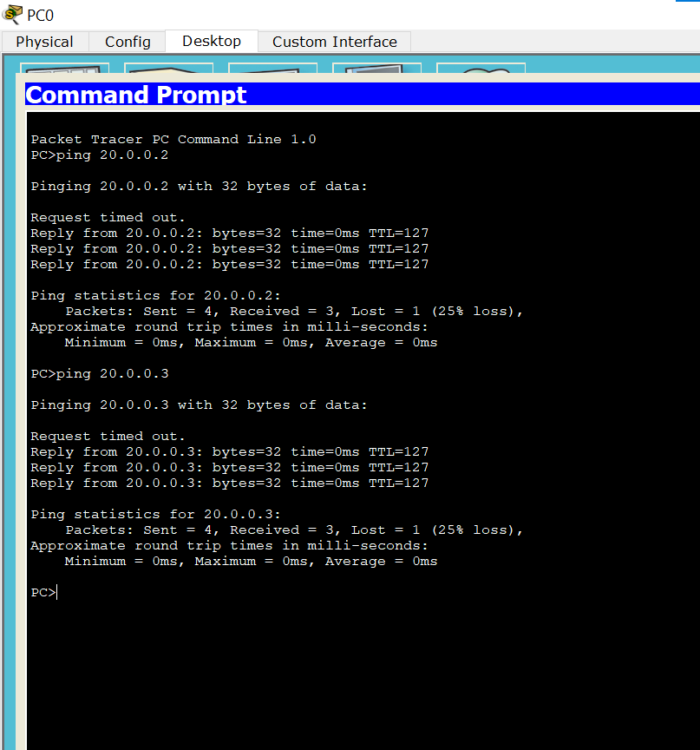

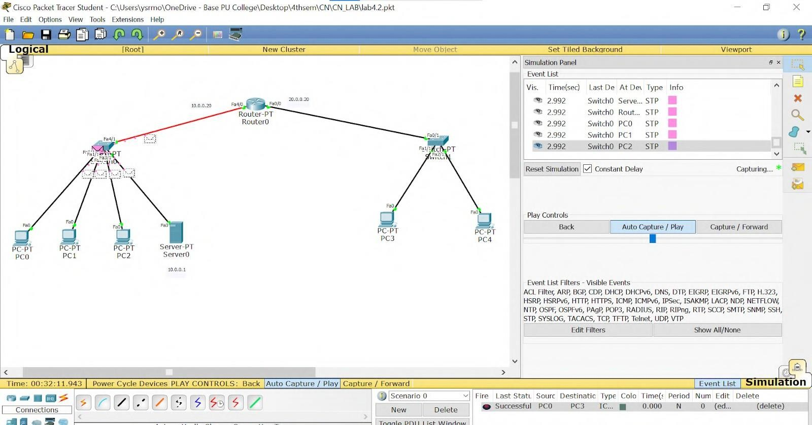

# WEEK 5

Configure Web Server, DNS within a LAN.

TOPOLOGY:

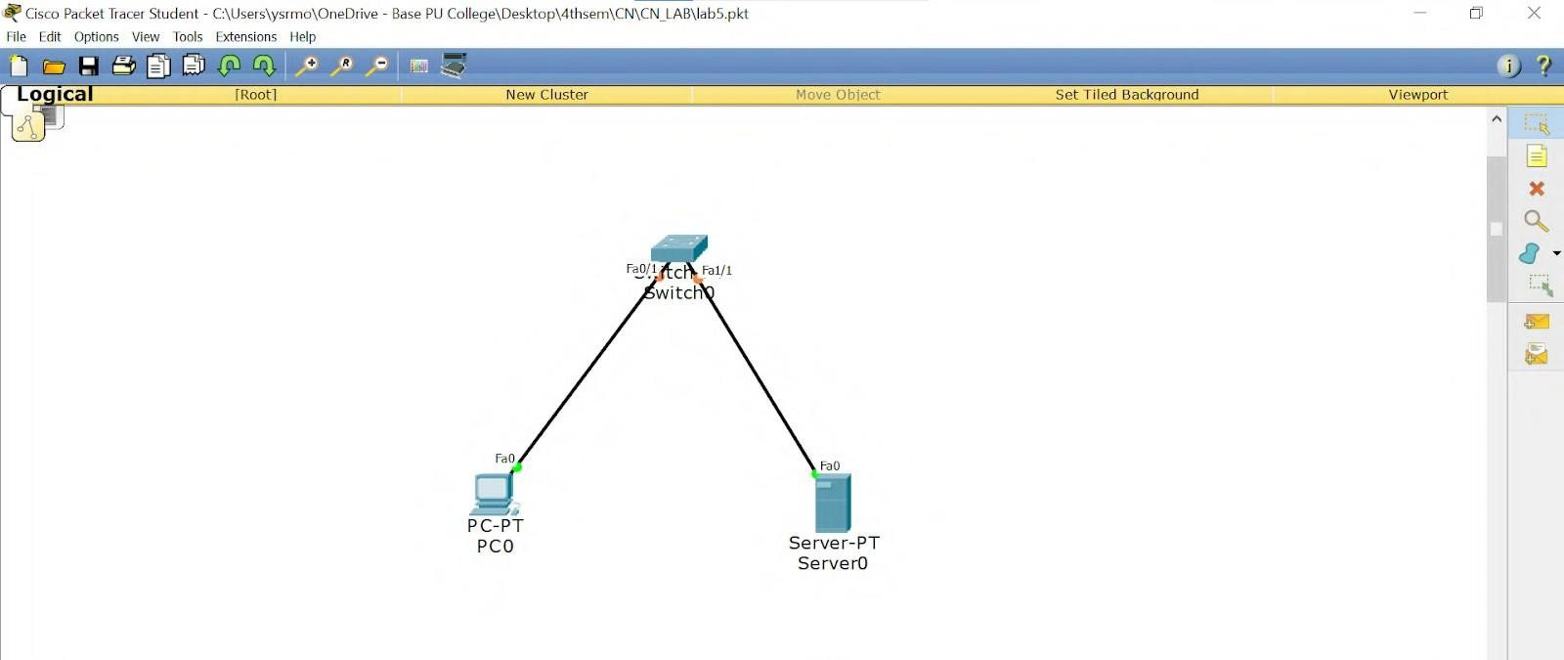

# WEEK 6

Configure RIP routing Protocol in Routers.

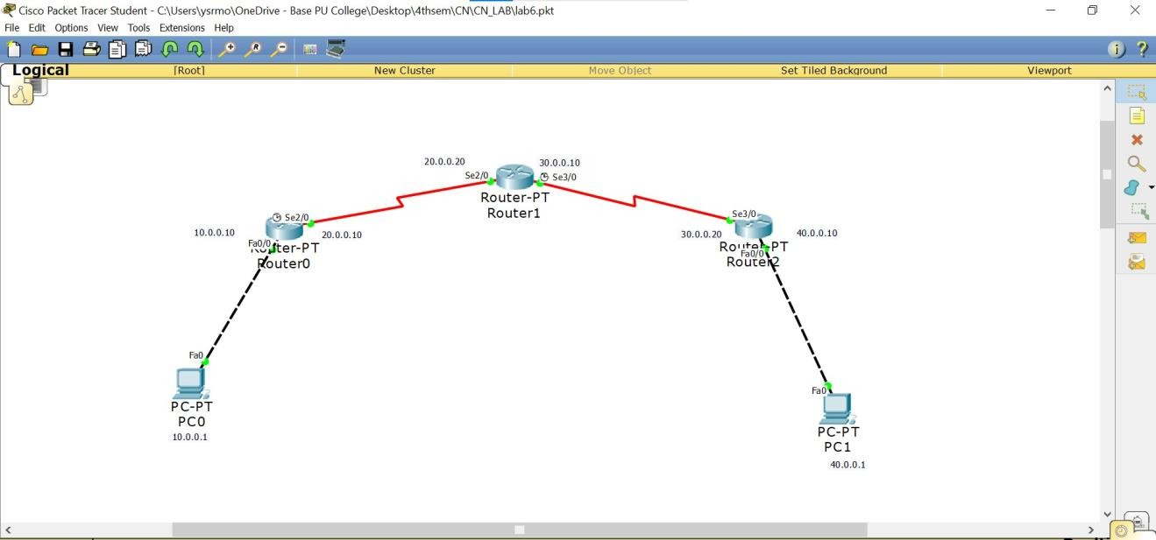TOPOLOGY:

OUTPUT:

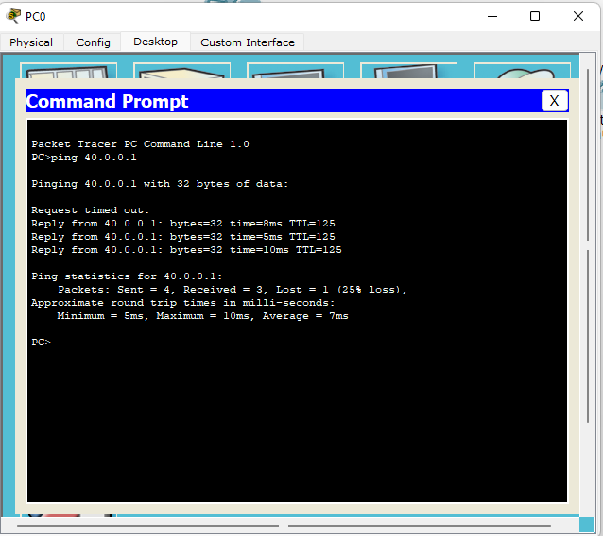

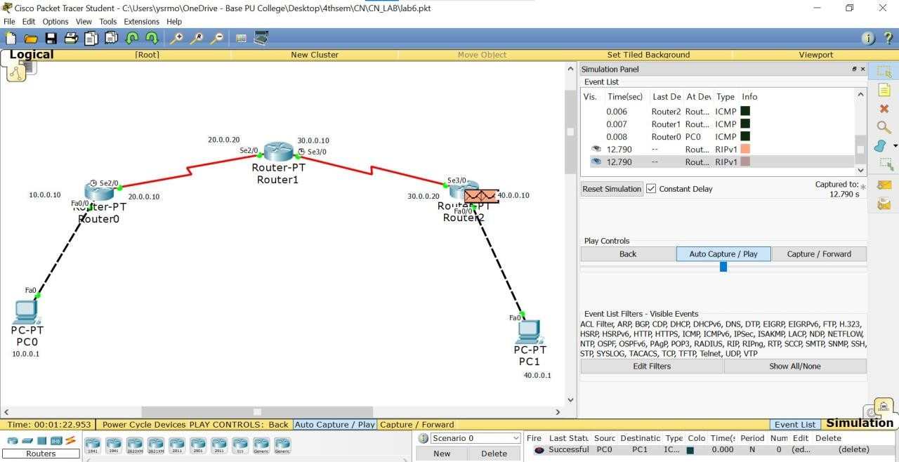

# WEEK 7

Configure OSPF routing protocol.

TOPOLOGY:

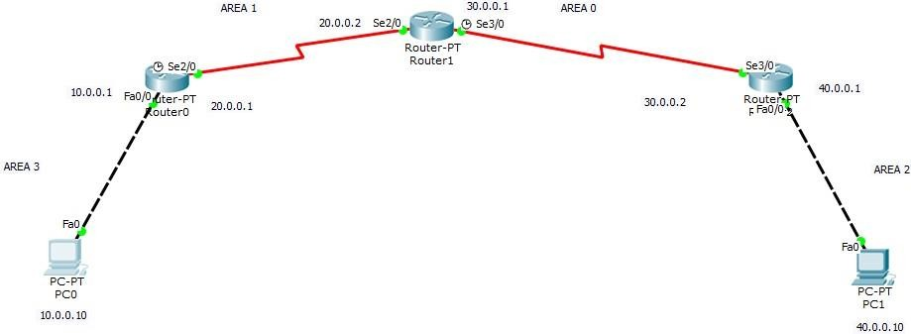

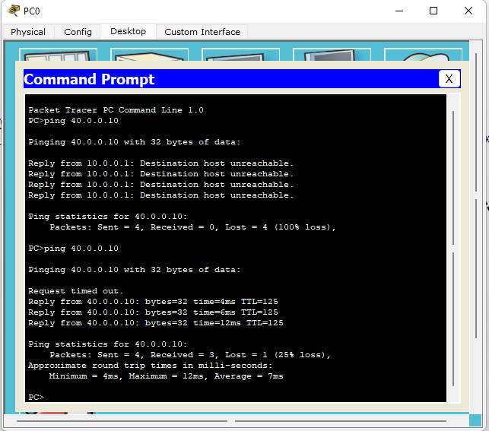OUTPUT:

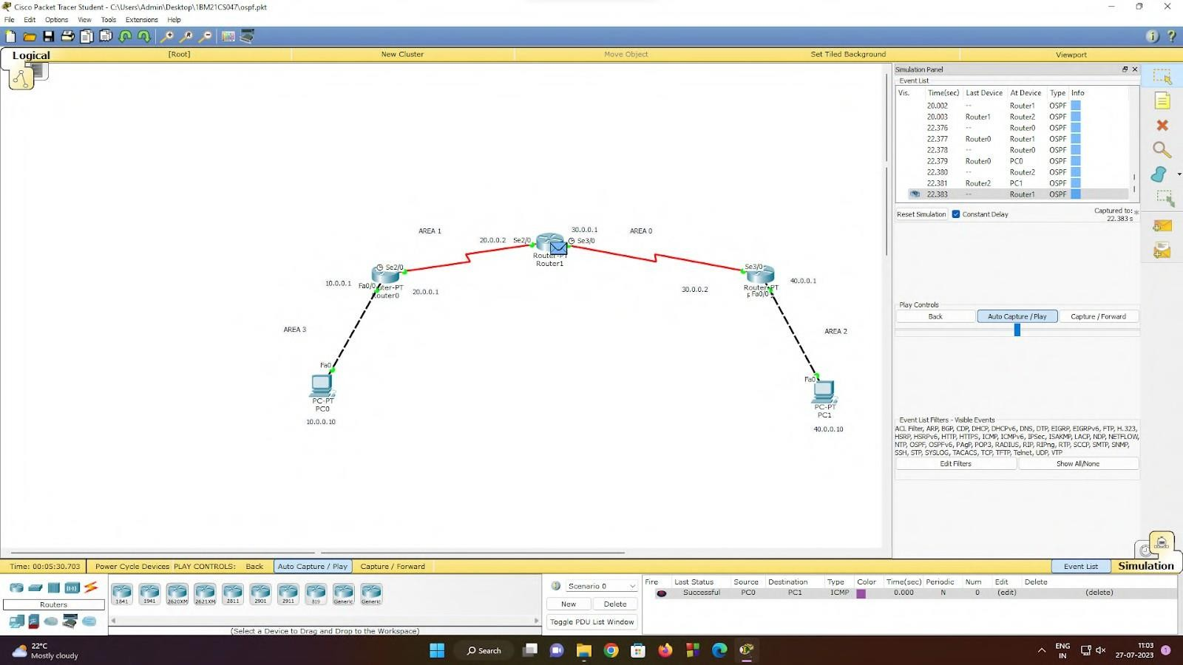

# WEEK 8

To construct a simple LAN and understand the concept and operation of Address Resolution Protocol (ARP).

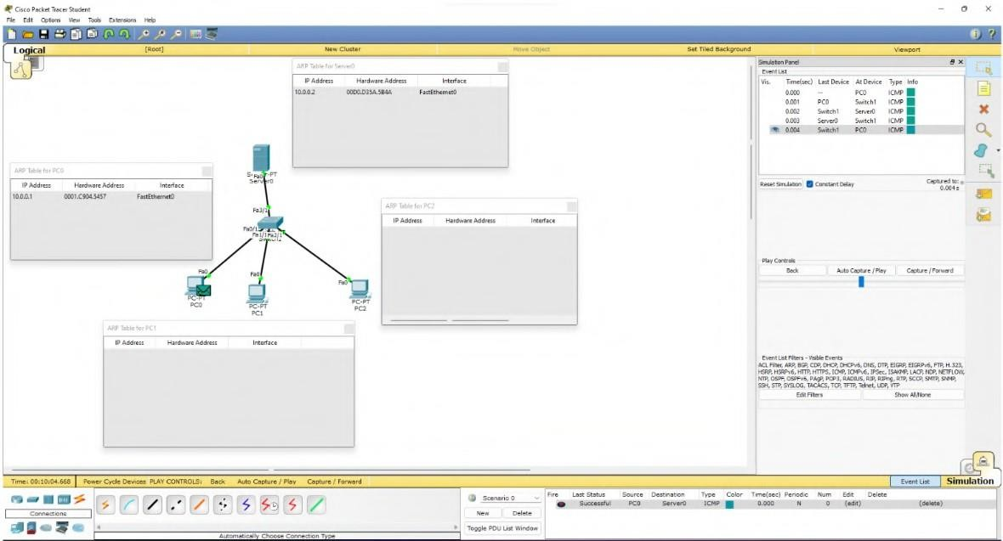TOPOLOGY:

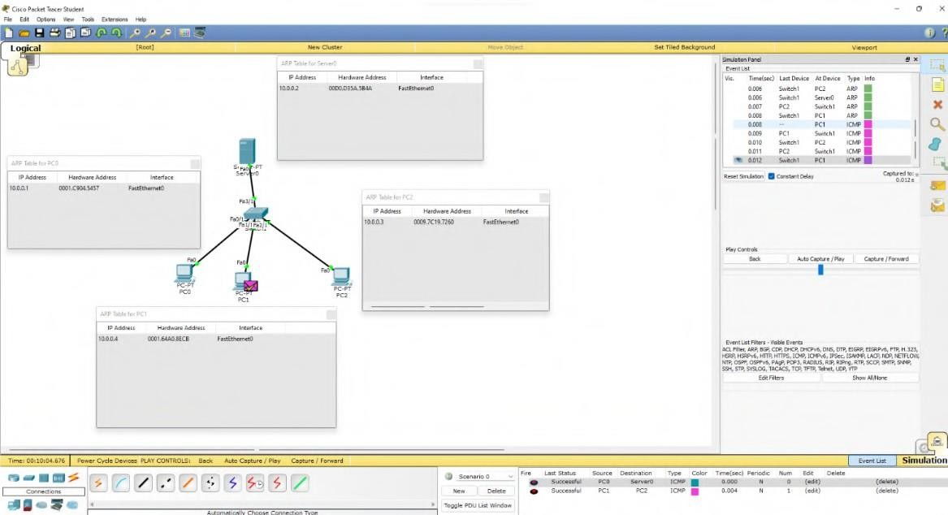OUTPUT:

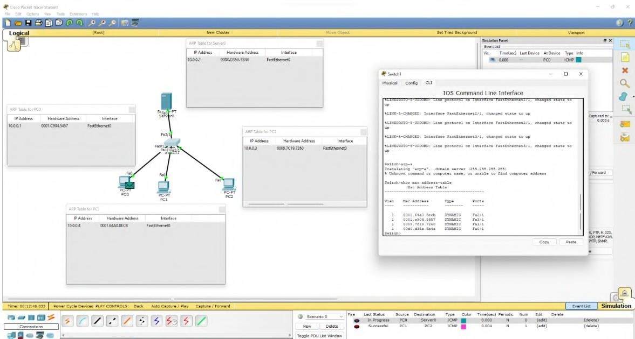

# WEEK 9

To construct a VLAN and make a pc communicate among VLAN.

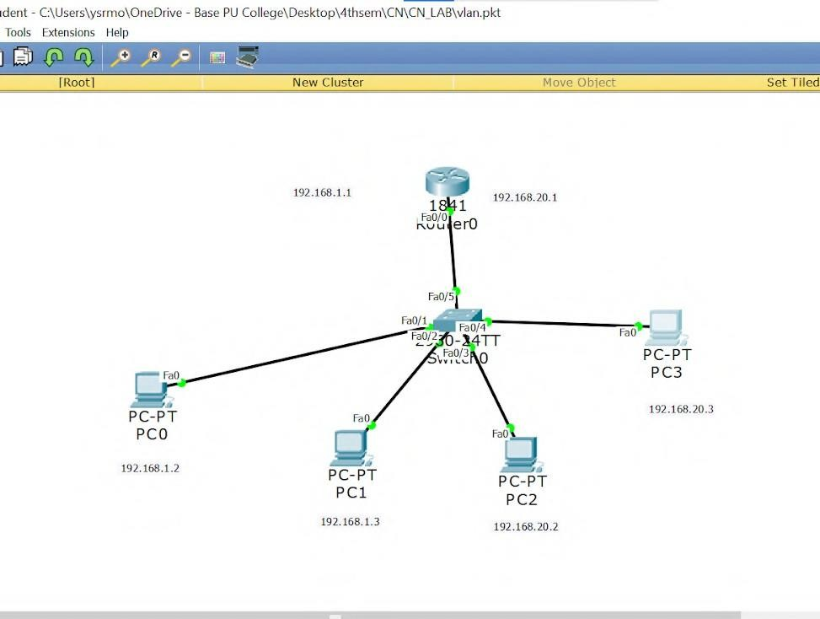TOPOLOGY:

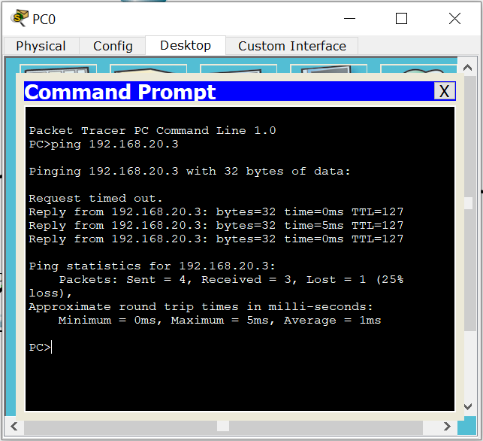OUTPUT:

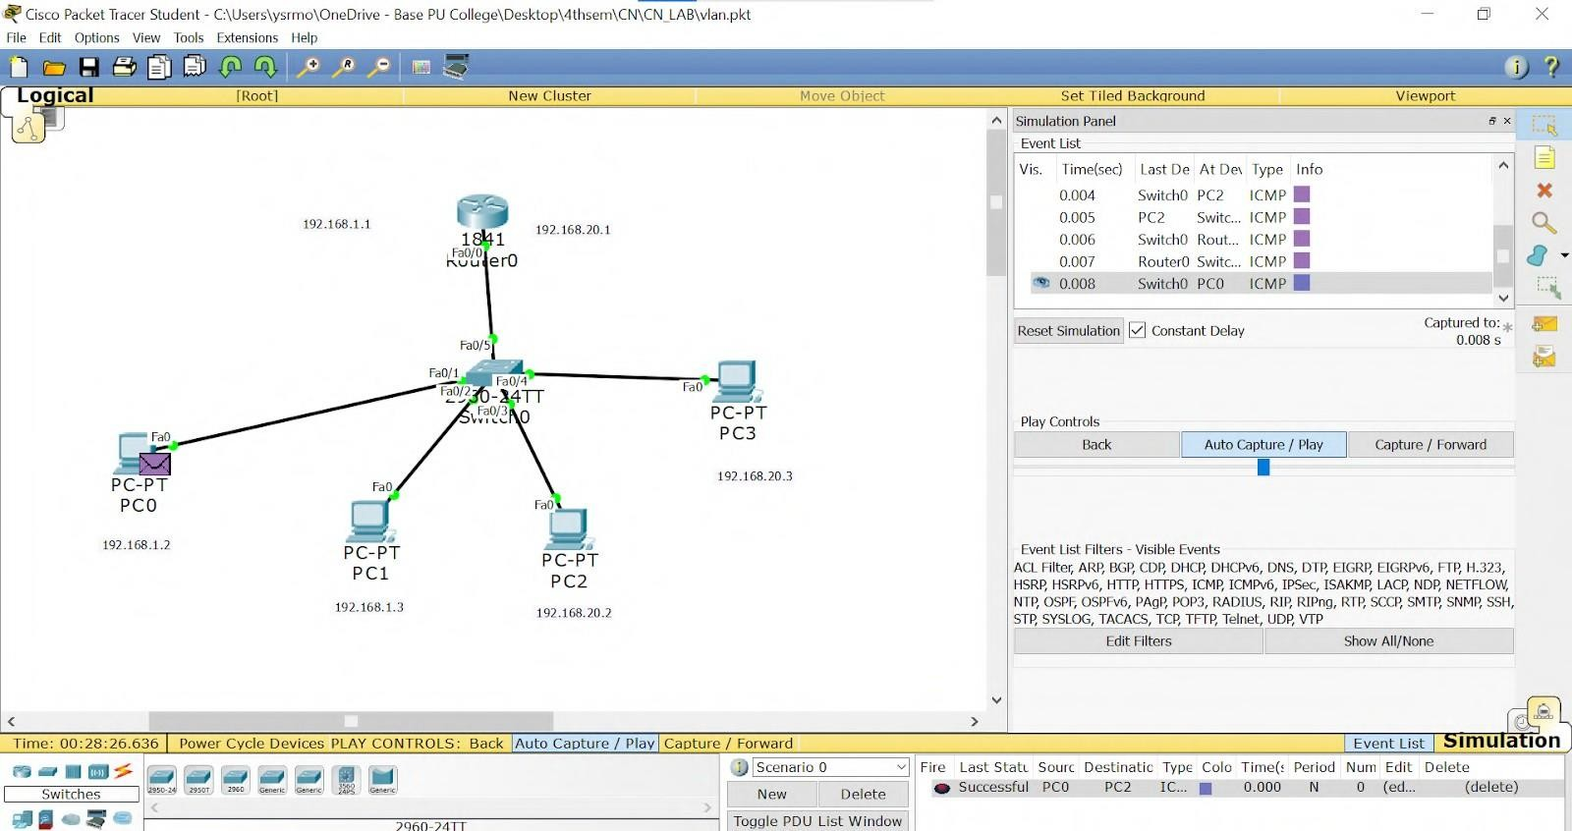

# WEEK 10

Demonstrate the TTL/ Life of a Packet.

TOPOLOGY:



OUTPUT:

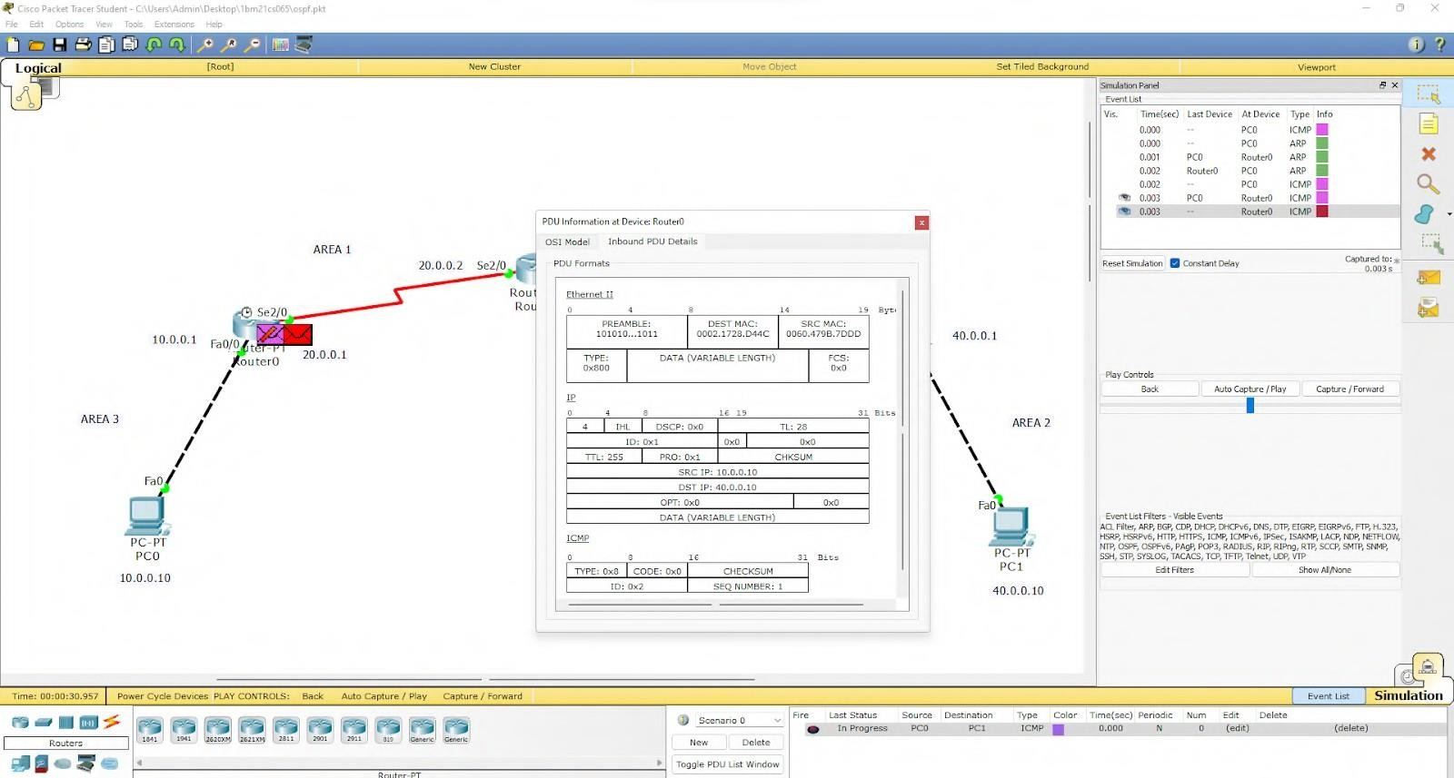

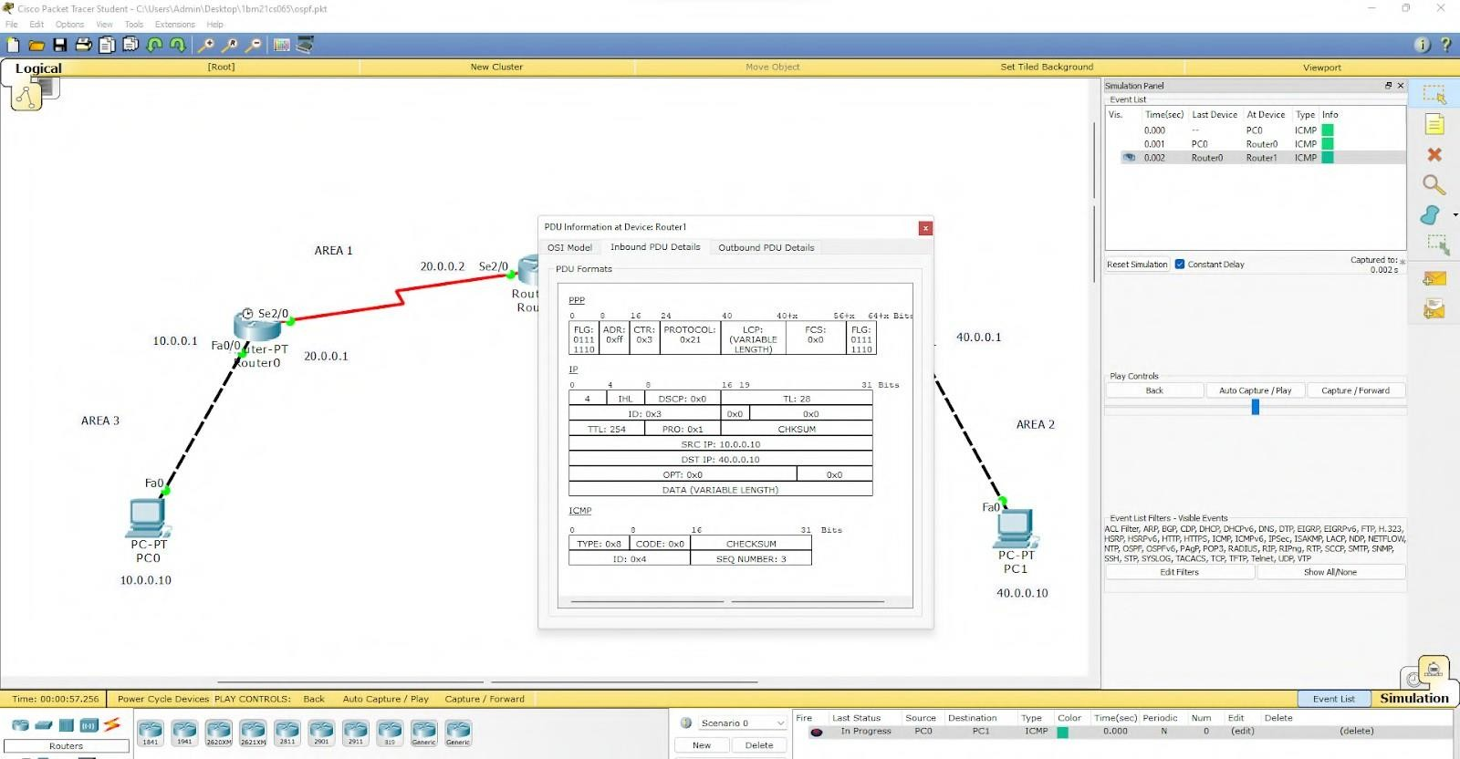

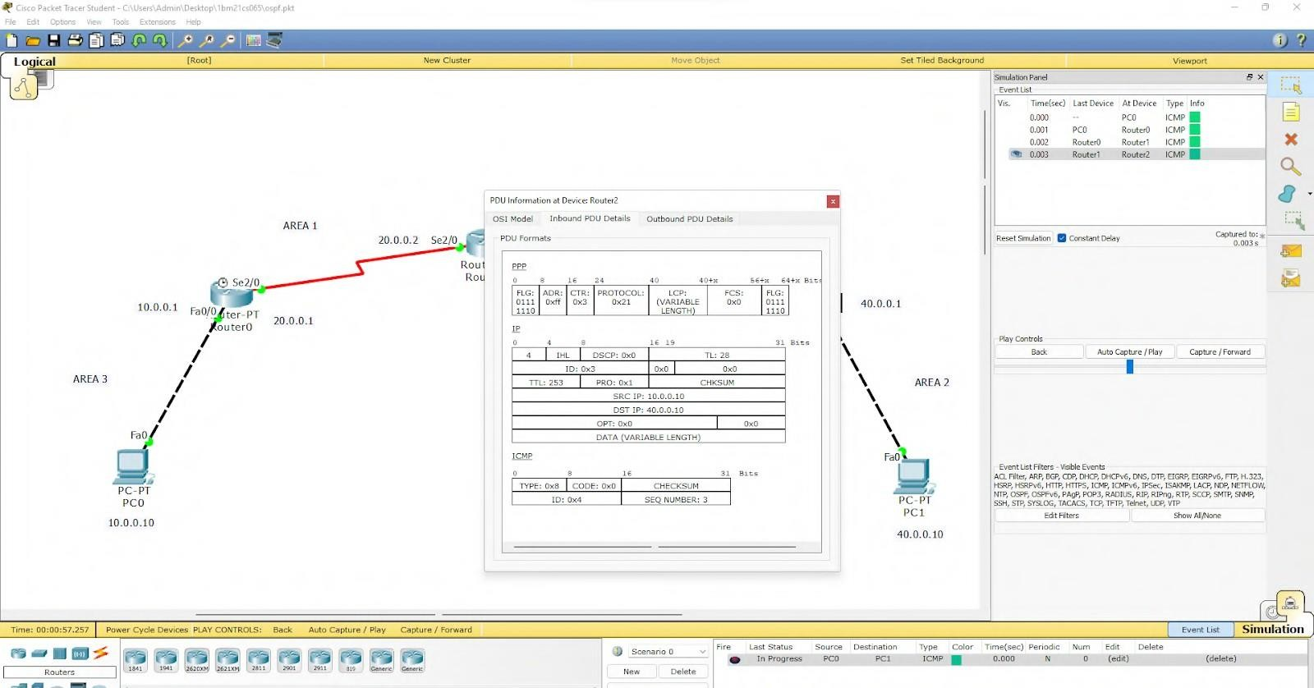

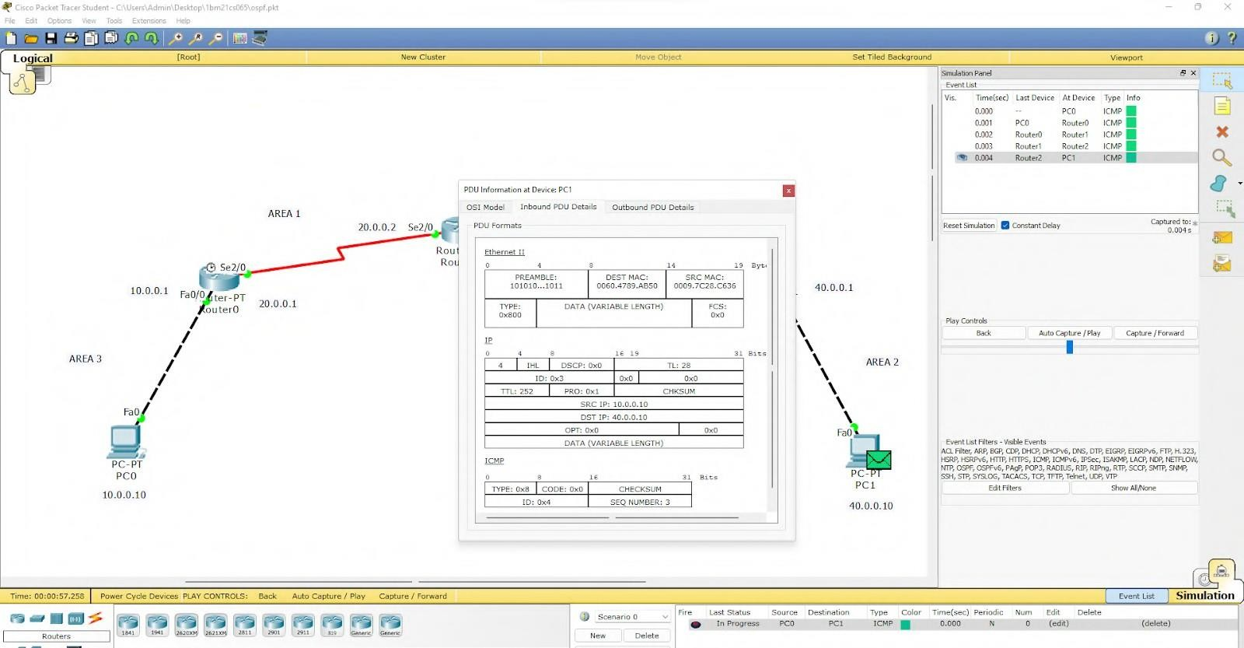

# WEEK 11

To construct a WLAN and make the nodes communicate wirelessly

TOPOLOGY:

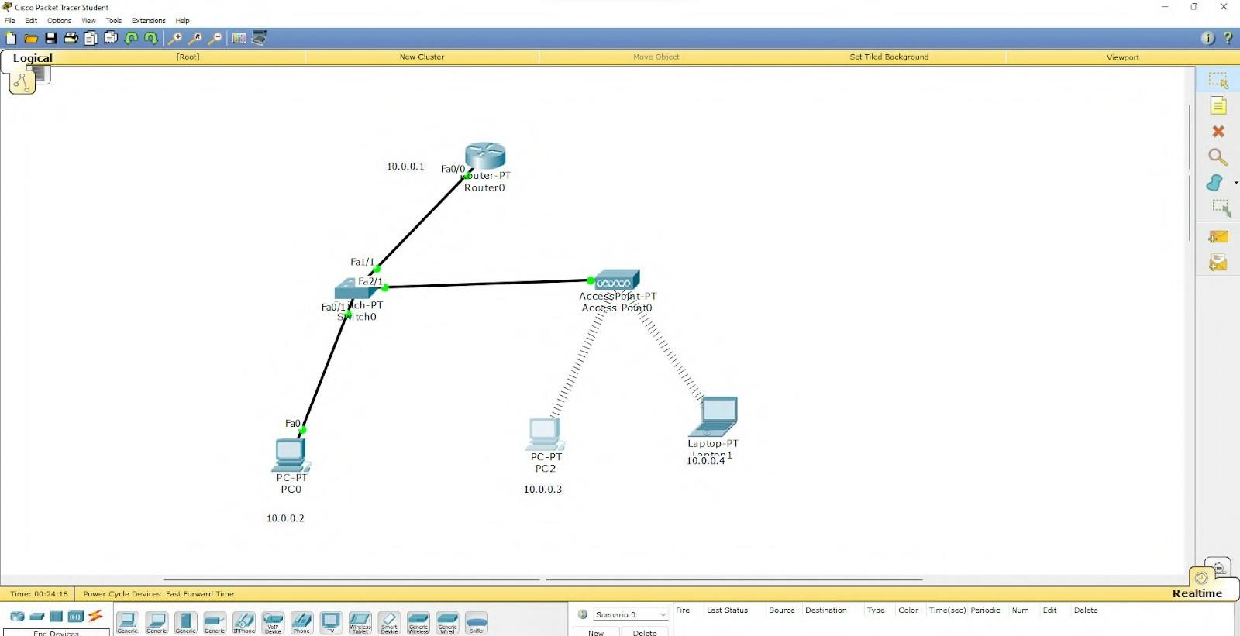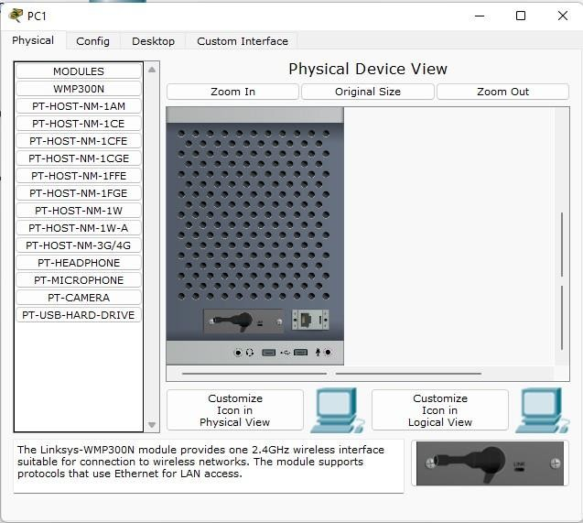

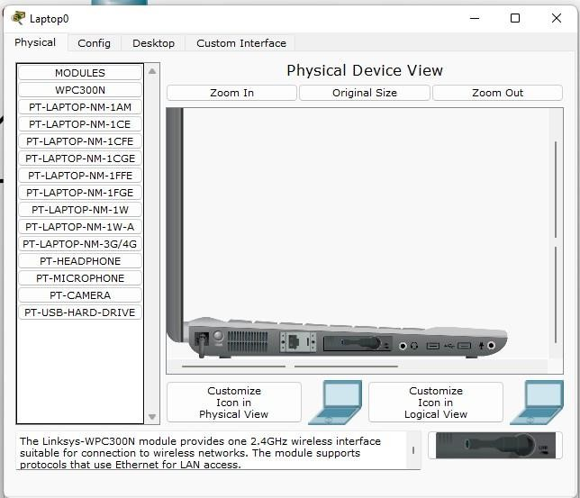

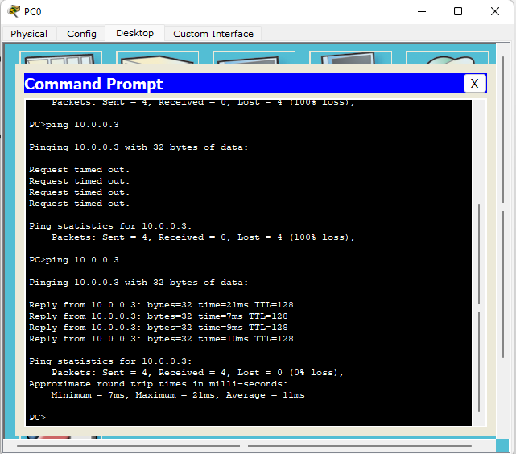OUTPUT:

# WEEK 12

To understand the operation of TELNET by accessing the router in server room from a PC in IT office.

TOPOLOGY:

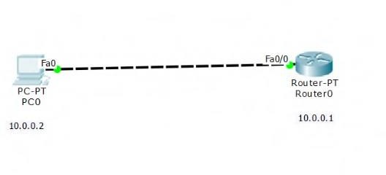

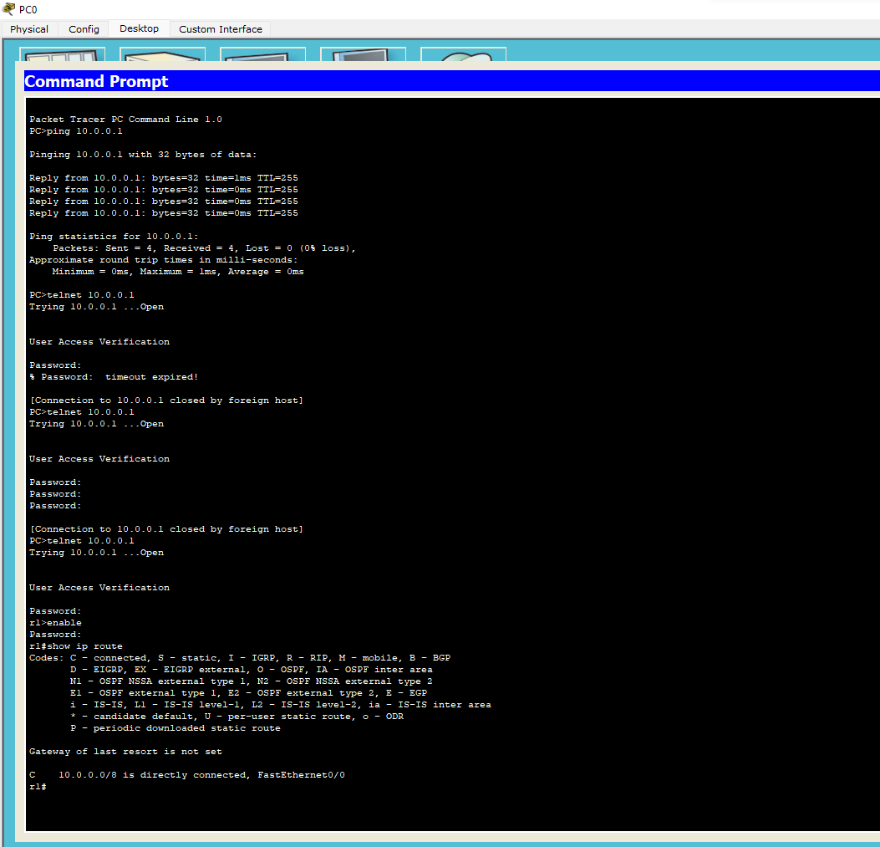OUTPUT:

# WEEK 13

Write a program for error detecting code using CRC- CCITT (16-bits).

OUTPUT:

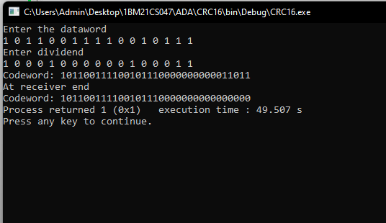

# WEEK 14

Write a program for congestion control using leaky bucket algorithm CODE:

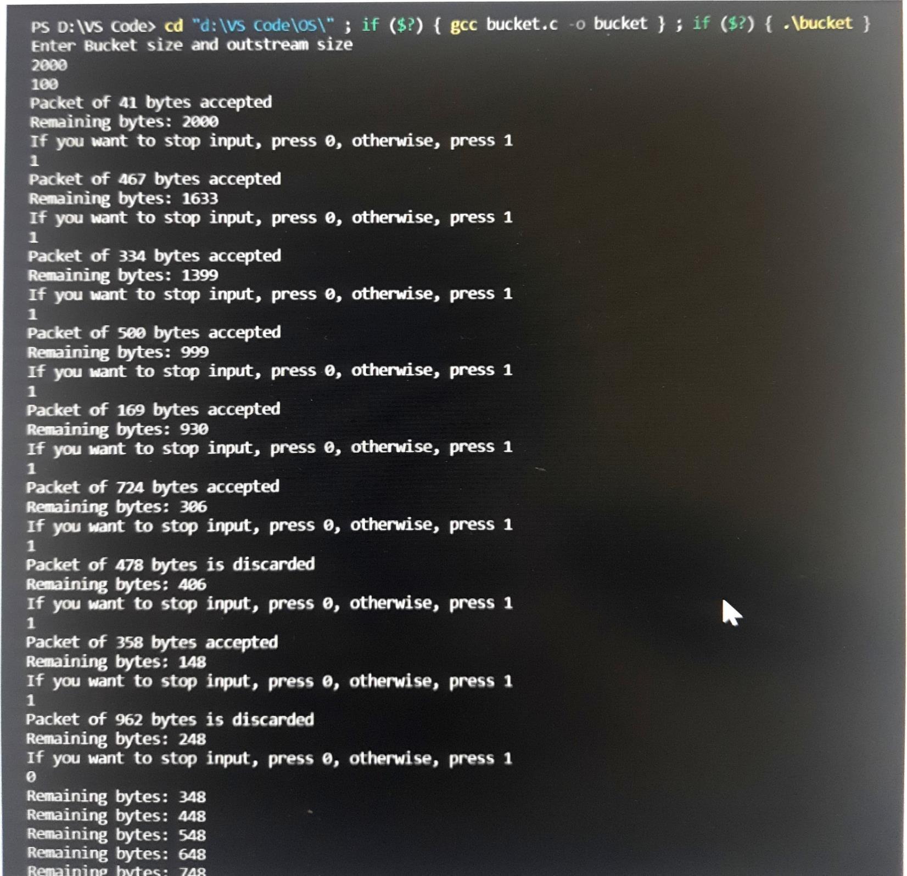

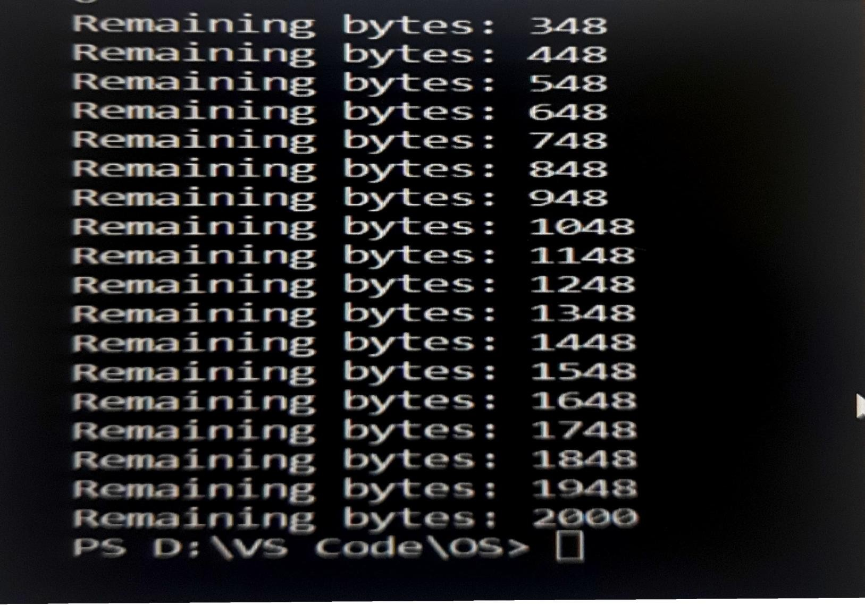

# WEEK 15

Using TCP/IP sockets, write a client-server program to make client sending the filename and the server to send back the contents of the requested file if present.

OUTPUT:

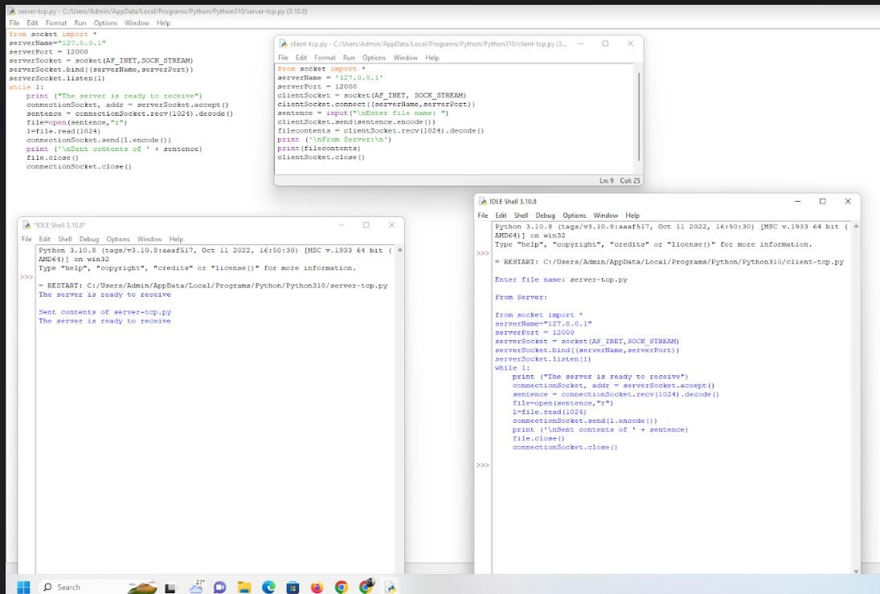

# WEEK 16

Using UDP sockets, write a client-server program to make the client send the file name and the server to send back the contents of the requested file if present.

# OUTPUT:

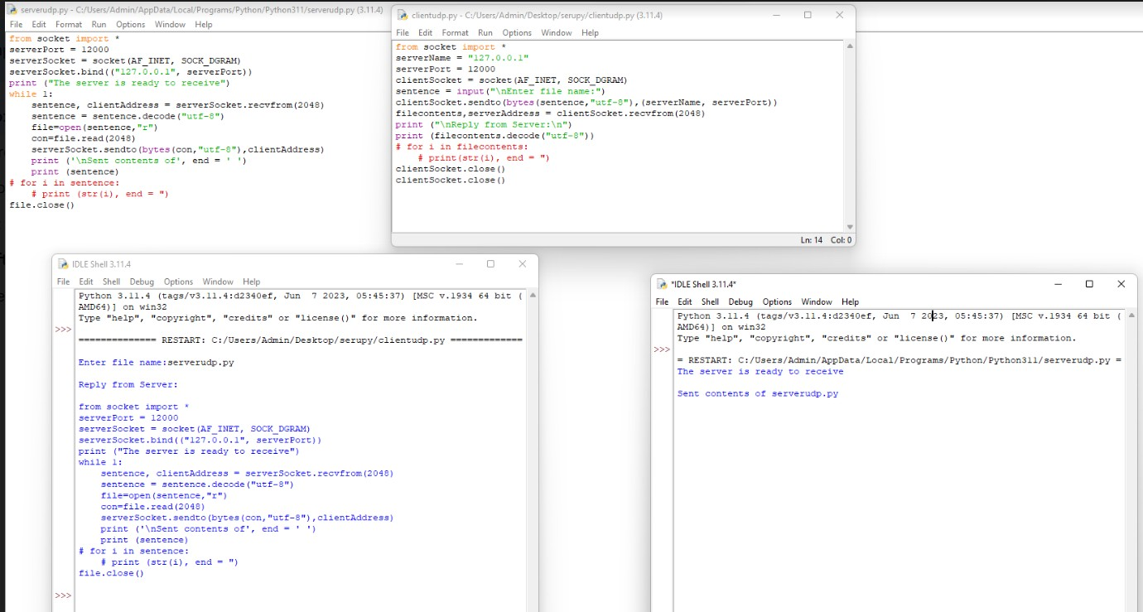

**WEEK 17**

Tool Exploration -Wireshark